**ASSIGNMENT-4**

**DISTANCE DETECTION USING ULTRASONIC**

**SENSOR**

| Date | 22 October 2022 |
| --- | --- |
| Team ID | PNT2022TMID18390 |
| Name | Manoj Kumar A |
| Student Roll Number | 1919102082 |
| Maximum Marks | 2 Marks |

Question1:

Write code and connections in work for ultrasonic sensor. Whenever distance is less than 100 cms send "alert" to ibm cloud and display in device recent events.

WOKWI LINK:

https://wokwi.com/projects/305566932847821378

CODE :

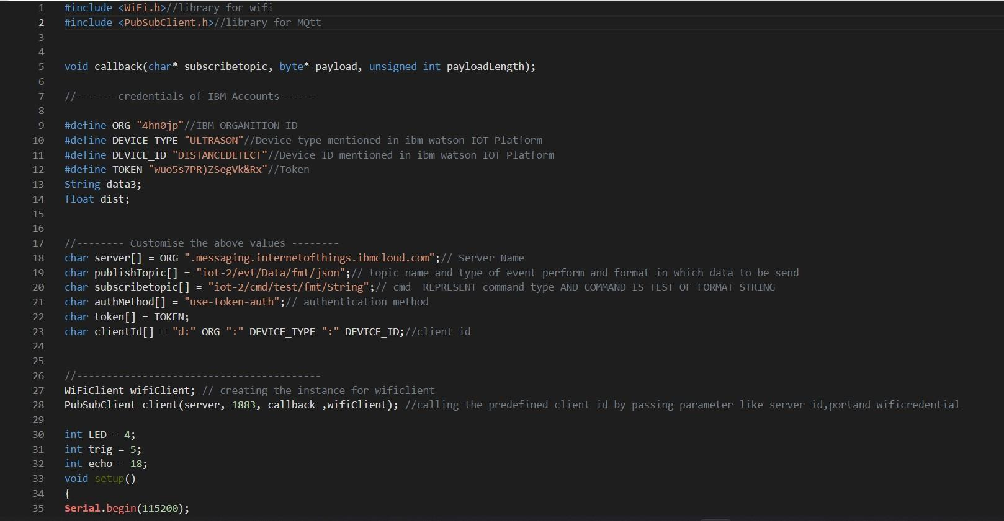

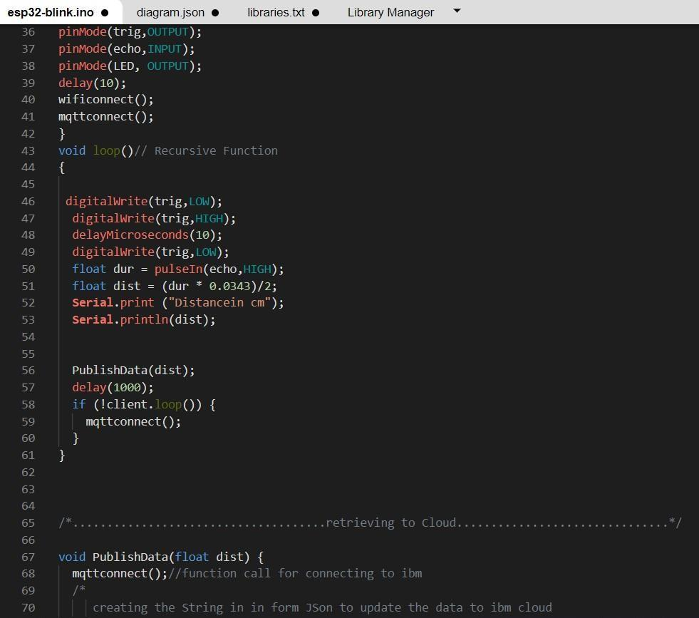

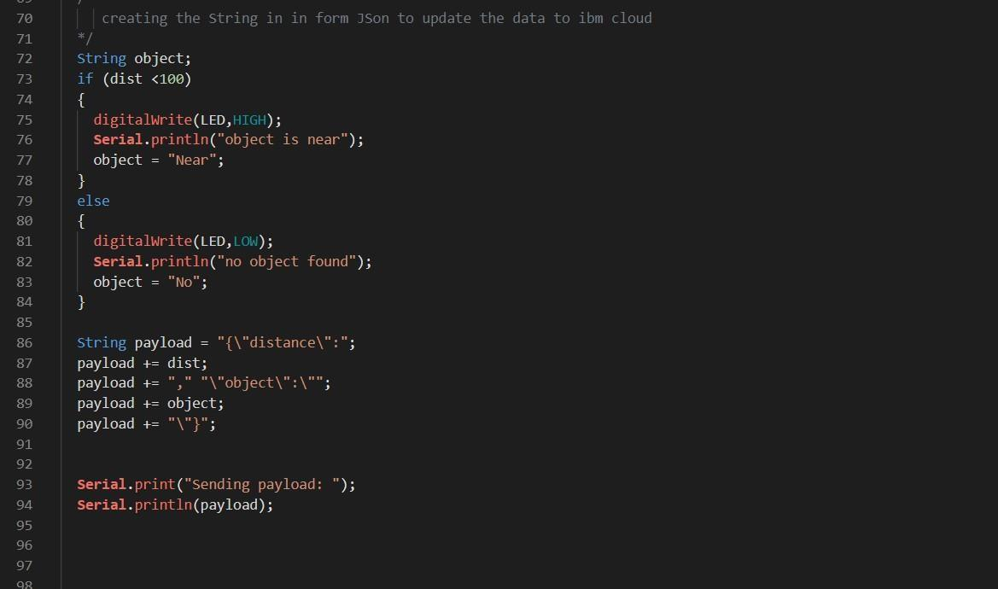

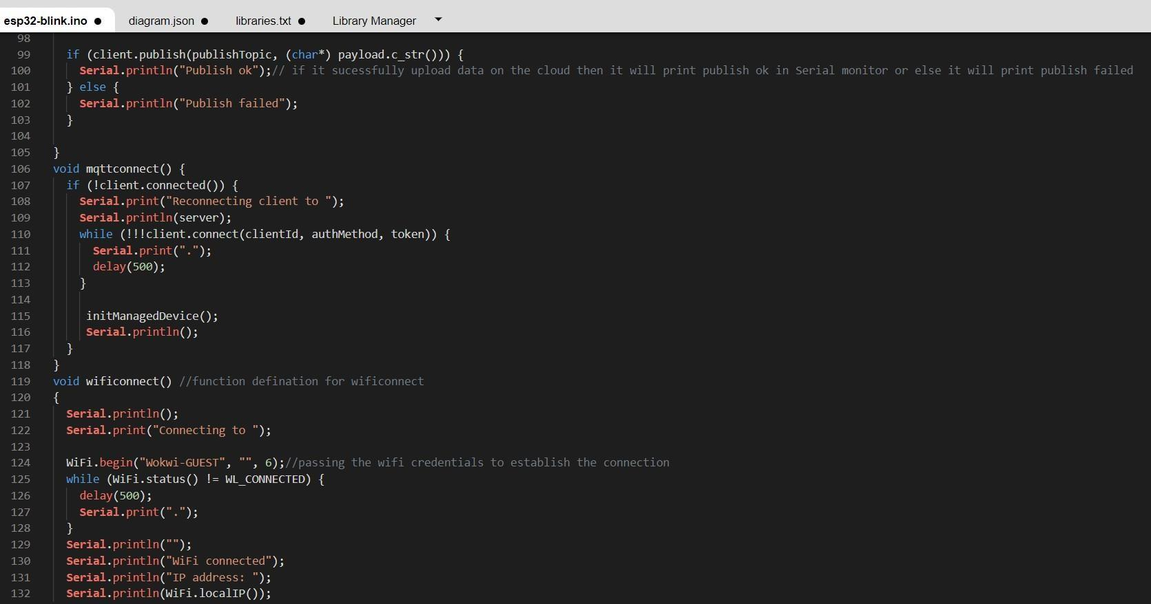

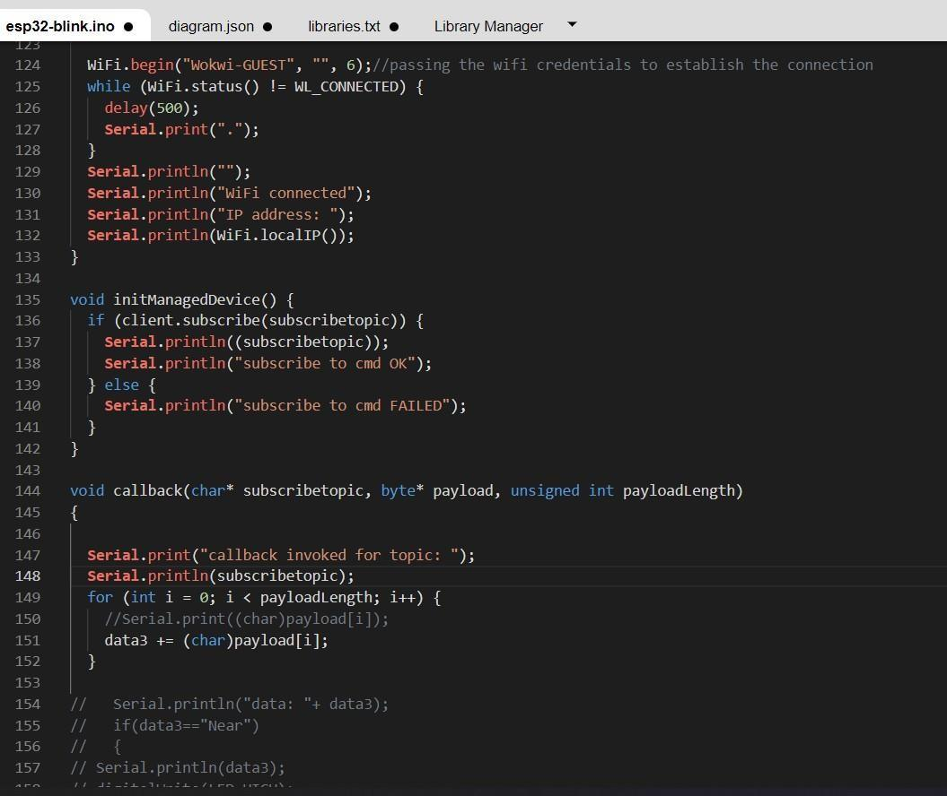

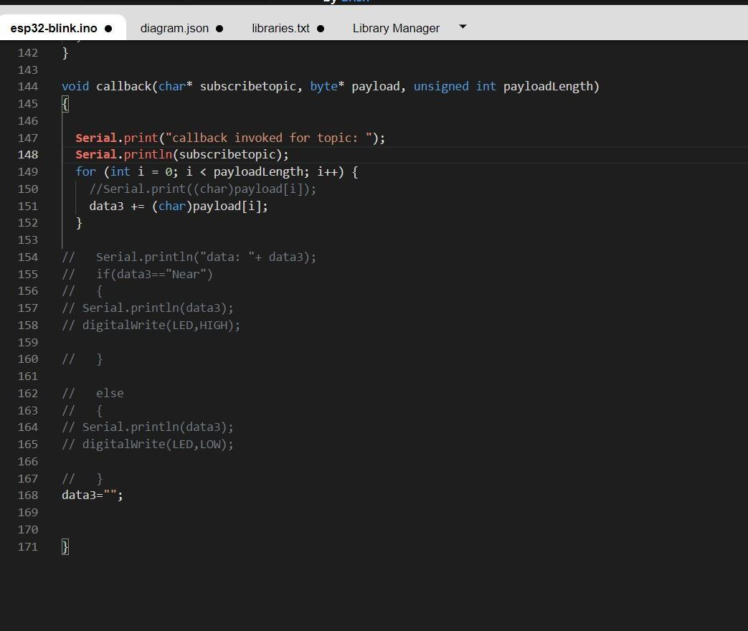

OUTPUT:

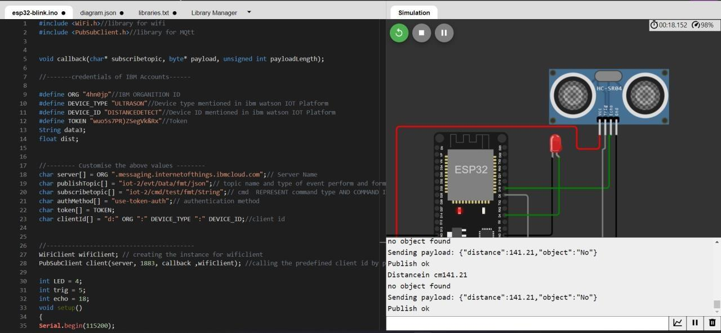

# Data send to the IBM cloud device when the object is far

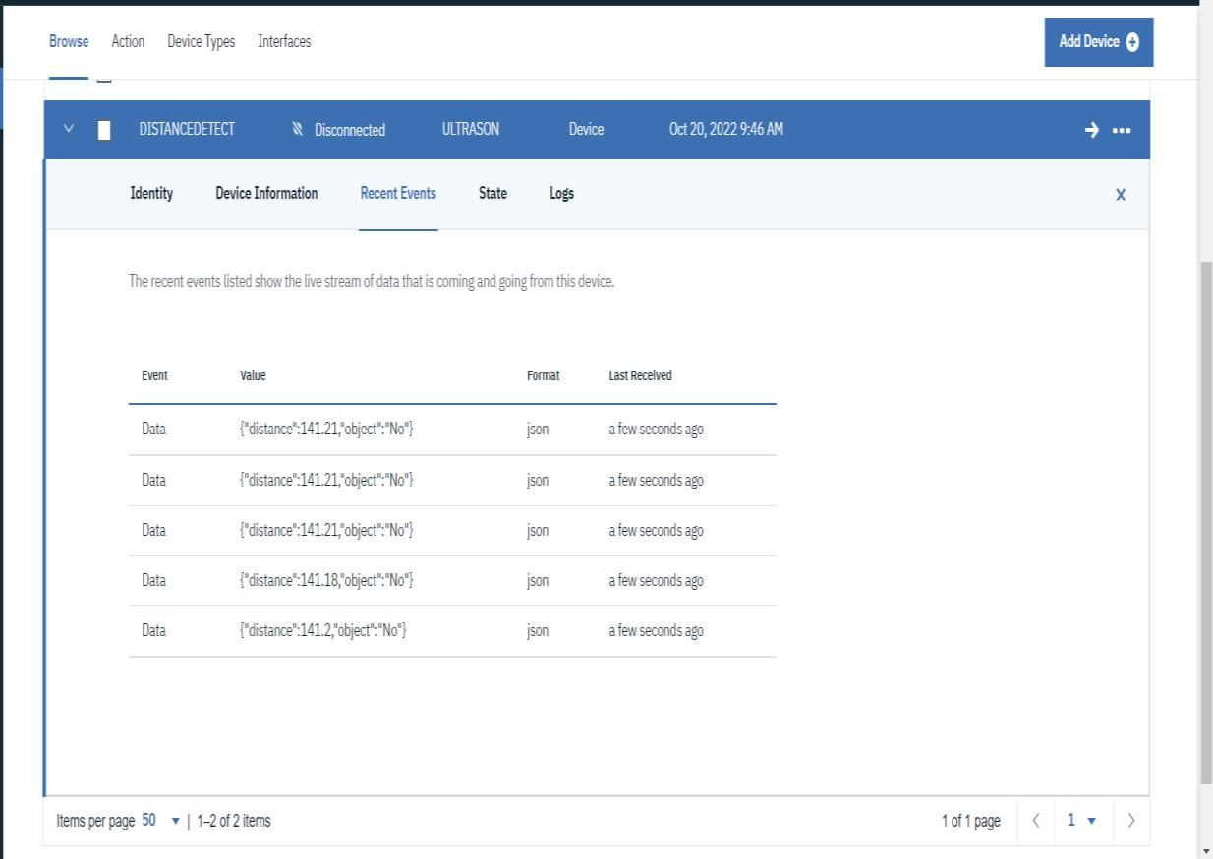

# when object is near to the ultrasonic sensor

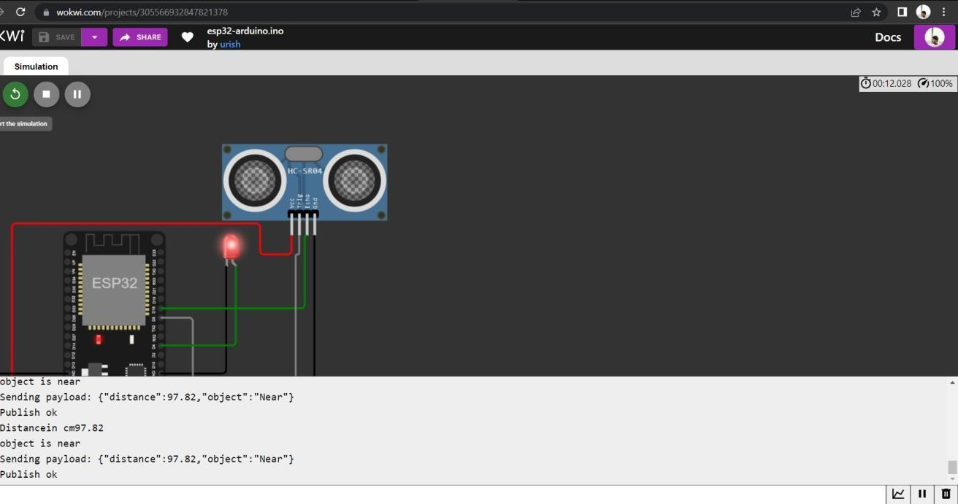

# Data sent to the IBM Cloud Device when the object is near

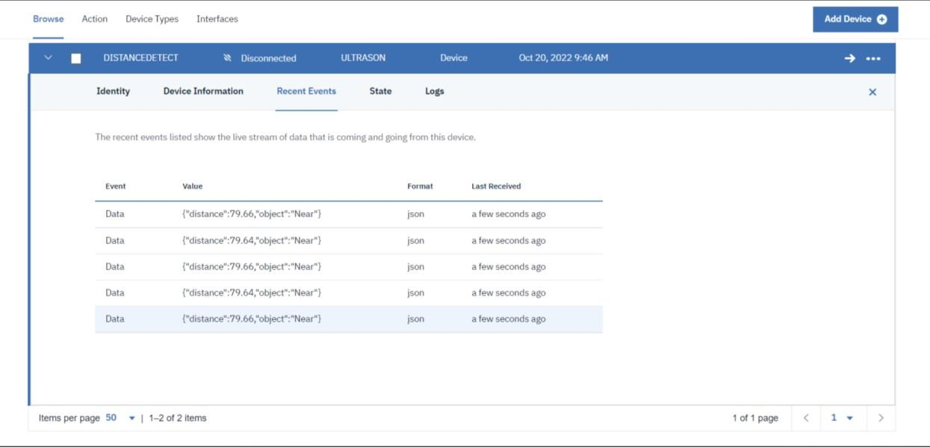

# https://wokwi.com/projects/305566932847821378